2016 Kidding Schedule

Does in blue shaded boxes are registered Nigerian Dwarf goats.
Does in pink shaded boxes are registered Nigerian Dwarf goats, but kids are ineligible for registration.
Does in red shaded boxes are unregistered, purebred Nigerian dwarfs.
Does in green shaded boxes are pygmy or Nigerian/pygmy crosses.
We reserve the right to retain any and all kids from a breeding.
The information provided is only to show the potential availability of kids.
Prices are provided as a courtesy only and in no way implies that a given kid is for sale.
Kids available for sale will be posted to a 2016 Kid page when they reach the age of 9 weeks (or greater if more mom time is required to insure the health of the kid).
Please do not contact us to reserve a kid at this time.
We want all our kids to be healthy and ready to go before we promise them to anyone. Some may be delayed in posting due to their requiring more time with mom to reach a healthy weight. This is particularly true of multiples, especially triplets and quads.
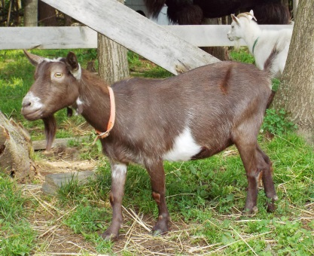 | Roundabout Mun Kee Cee  DOB: 4/23/2008  AGS D-43006 | Sire: Roundabout Yin Yang  AGS D-26392  Dam: Roundabout Sassafras  AGS D-16050 | Stud: O’Henry  Kidded 5/27/2016  1 kid DOA
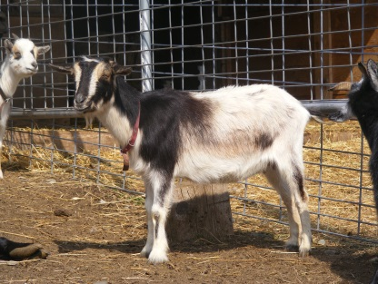 | Dragonfly RY Ashling  DOB: 6/30/2008  AGS D-46728  ADGA D1503628 | Sire: Caesar’s Villa Rebel Yell *S  AGS D-37944  Dam: Dragonfly Leprechaun’s Ceili  AGS D-32947  ADGA D1470152 | Stud: O’Henry  Kidded 5/10/2016  2 bucks- JM Farm OH Andes  JM Farm OH Aero  BOTH SOLD
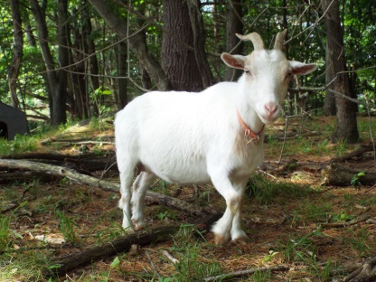 | Birch Ridge Farm TC Thumper  DOB: 5/6/2010  AGS D-53513  ADGA D1540310 | Sire: Bombahook Acres Triple Crown *S  AGS D-44708  Dam: Roundabout Bambi  AGS D-20702 | Stud: O’Henry  Kidded 5/19/2016  1 Doe JM Farm OH Taffy RETAINED  2 Bucks- JM Farm OH Tart N Tiny RETAINED  JM Farm OH Twizzler  SOLD
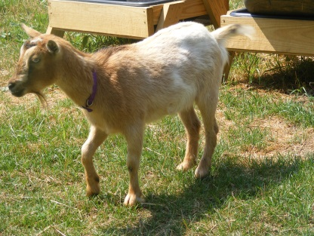 | Fittin’ it in Farm T Dahlia  DOB: 4/14/2011  AGS D-59822 | Sire: God’s Love Farm A Timothy  AGS D-52321  Dam: Primrose Park Rose  AGS D-39160 | Stud: O’Henry  Kidded 7/11/2016  1 Doe JM Farm OH Divinity  RETAINED
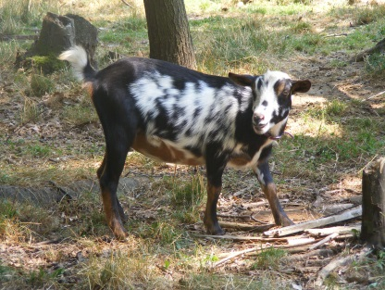 | Birch Ridge Farm Gemmalisa  DOB: 4/17/2011  AGS D-58280  ADGA D1575460 | Sire: Dragonfly IH Aonghas Mac Og *S  AGS D-41969  Dam: Merry Legs Farm She’s a Jem  AGS D-54096 | Stud: O’Henry  Kidded 4/27/2016  2 Does- JM Farm OH Godiva  JM Farm OH Galaxy  BOTH RETAINED  2 Bucks- JM Farm OH GooGoo Cluster buck $250 or wether $150 ADGA & AGS eligible  JM Farm OH Ghiradelli  DECEASED
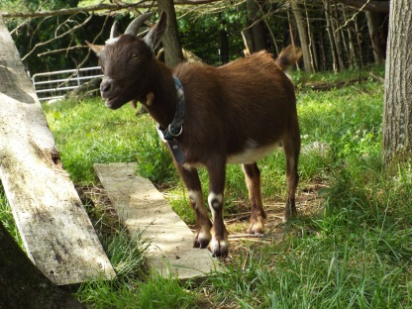 | JM Farm MB Waltzin’ Matilda  DOB: 3/1/2013  AGS D-74289  ADGA D1705650 | Sire: Birch Ridge Farm MM Moon Beam  AGS D-58026  ADGA D1575463  Dam: Roundabout Mun Kee Cee  AGS D-43006 | Stud: O’Henry  Kidded 5/1/2016  2 Does- JM Farm OH Neapolitan & JM Farm OH M E M  BOTH RETAINED
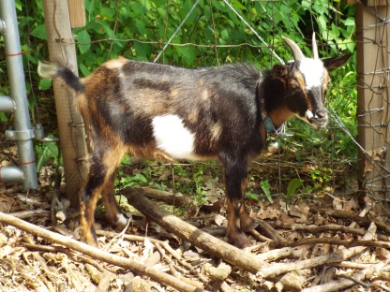 | JM Farm MB Crocus  DOB: 4/17/2013  AGS D-74290  ADGA D1704163 | Sire: Birch Ridge Farm MM Moon Beam  AGS D-58026  ADGA D1575463  Dam: Birch Ridge Farm See No Evil  AGS D-55641  ADGA D1550690 | Stud: O’Henry  Kidded 7/2/2016  1 buck- JM Farm OH Chuckles  Buck $200  Wether $150  ADGA & AGS eligible
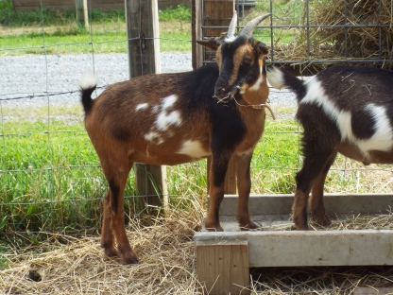 | JM Farm MB Charlotte  DOB: 3/4/2014  ADGA D1746074  AGS reg. pending | Sire: Birch Ridge Farm MM Moon Beam  AGS D-58026  ADGA D1575463  Dam: Sunnydale Farm Cordelia  AGS D-37946  ADGA D1441908 | Stud: O’Henry  Kidded 5/6/2016  1 Doe-DOA
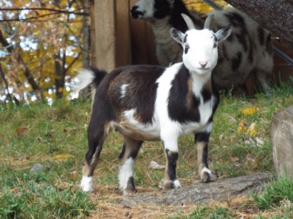 | JM Farm MB Margaret  DOB: 3/19/2014  ADGA & AGS reg. pending | Sire: Birch Ridge Farm MM Moon Beam  AGS D-58026  ADGA D1575463  Dam: Roundabout Mun Kee Cee  AGS D-43006 | Stud: O’Henry  Kidded 4/26/2016  1 doe- DOA
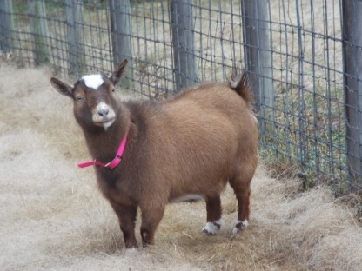 | Breezy Meadow Farm R Izabella  DOB: 3/15/2010  AGS D-68542 | Sire: Ponds Edge HR Ronni  Dam: Wandering Ivy CM Bella | Stud: O’Henry  Kidded 4/17/2016  Kids not eligible for registration  1 Doe JM Farm OH JellyBelly SOLD  1 buck JM Farm OH JuJuBe  SOLD
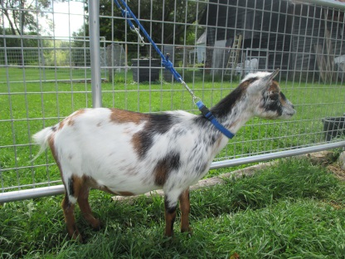 | Cottrell Farm Hua  DOB: 3/8/2012  unregistered | Sire: Rosasharn BB  ADGA D1541458  Dam: Twinkle Farm Violet  ADGA D1528853 | Stud: O’Henry  Kidded 4/15/2016  1 buck JM Farm OH Hershey  Buck $150  or wethered $100
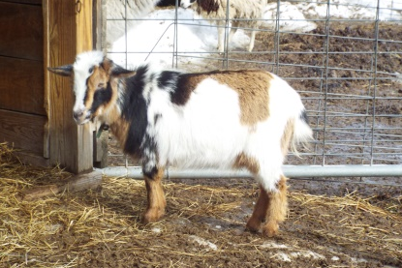 | Windigo Farm Bella  DOB: 6/7/2014  unregistered | Sire: Silk Tree Gus  Dam: Cottrell Farm Hua | Stud: O’Henry  Kidded 7/1/2016  1 Doe JM Farm OH Butterfinger  Doe $250
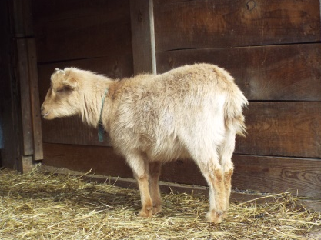 | Windigo Farm Cocoa  DOB: 6/9/2014  Unregistered Nigerian Dwarf | Sire: Silk Tree Gus  Dam: Cottrell Farm Fawn | Stud: O’Henry  Kidded 4/27/2016  1 wether- JM Farm OH Clark $100  1 doe- JM Farm OH Chiclet (bottle kid) $250
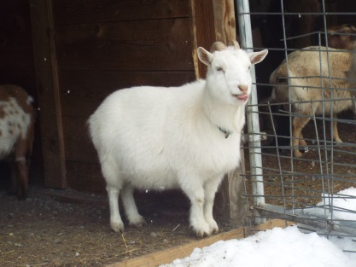 | Spot’s Thumbelina  DOB: 4/19/2007  F1 Pygmy/Nigerian cross | Sire: Spot  Pygmy goat  Dam: Kimberly  Nigerian dwarf | Stud: O’Henry  Kidded 4/29/2016  1 Buck- OH Toblerone  SOLD
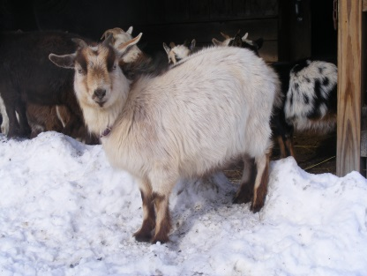 | BRH Precious II  DOB: 7/29/2011  F1 Pygmy/Nigerian cross | Sire: Birch Ridge Farm TC Howie  AGS D-53512  ADGA D1540309  Dam: Nippy  Pygmy goat | Stud: O’Henry  Kidded 4/20/2016  2 Does- OH Peeps & OH PixieStix BOTH SOLD  2 Bucks- OH Pearson Nips & OH PopRocks  BOTH SOLD
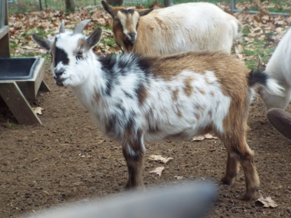 | MB Pretty in Pink  DOB: 2/27/2013  F1 Pygmy Nigerian cross | Sire: Birch Ridge Farm MM Moon Beam  AGS D-58026  ADGA D1575463  Dam: Spot’s Patches  Pygmy goat | Stud: O’Henry  Kidded 5/3/2016  1 buck-OH Palmer  SOLD
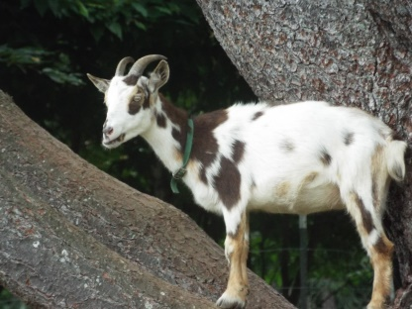 | MB Tabitha  DOB: 3/25/2014  75% Nigerian/25% Pygmy cross | Sire: Birch Ridge Farm MM Moon Beam  AGS D-58026  ADGA D1575463  Dam: Spot’s Thumbelina  F1 Pygmy/Nigerian cross | Stud: O’Henry  Kidded 4/23/2016  1 Wether- OH Twix  SOLD
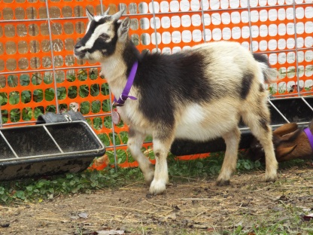 | JM Farm DW Gemmaline  DOB: 5/8/2015  ADGA D1805064  AGS reg. pending | Sire: JM Farm MB Dagwood  AGS D-69223  ADGA D1659346  Dam: Birch Ridge Farm Gemmalisa  AGS D-58280  ADGA D1575460 | Stud: O’Henry  Kidded 8/8/2016  1 Doe JM Farm OH Gummy Bear  RETAINED  1 Wether JM Farm OH Gobstopper $150  AGS eligible
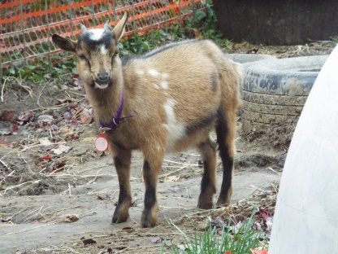 | JM Farm DW Gemmalynn  DOB: 5/8/2015  ADGA D1805065  AGS reg. pending | Sire: JM Farm MB Dagwood  AGS D-69223  ADGA D1659346  Dam: Birch Ridge Farm Gemmalisa  AGS D-58280  ADGA D1575460 | Stud: O’Henry  Due October?  Don’t believe she is pregnant  Does $300  Bucks NA  Wethers $150
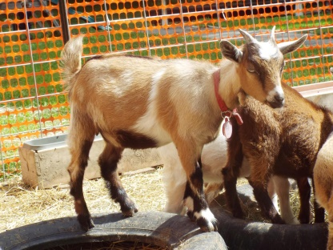 | JM Farm DW Molly Malone  DOB: 4/20/2015  ADGA & AGS reg. pending | Sire: JM Farm MB Dagwood  AGS D-69223  ADGA D1659346  Dam: Roundabout Mun Kee Cee  AGS D-43006 | Stud: O’Henry  Kidded 8/11/2016  1 Wether JM Farm OH Mars  $150  AGS eligible
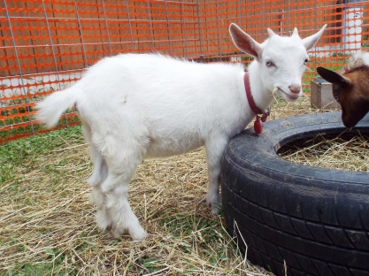 | DW Tinker Belle  DOB: 5/8/2016  75% Nigerian/25% Pygmy cross | Sire: JM Farm MB Dagwood  AGS D-69223  ADGA D1659346  Dam: Spot’s Thumbelina  F1 Nigerian/pygmy cross | Stud: O’Henry  Due October?  Don’t believe she is pregnant  Does $200  Bucks NA  Wethers $75
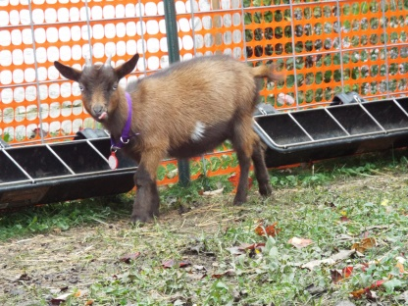 | DW Masquerade  DOB: 5/12/2015  75% Nigerian/25% Pygmy cross | Sire: JM Farm MB Dagwood  AGS D-69223  ADGA D1659346  Dam: BRH Precious II  F1 Nigerian/Pygmy cross | Stud: O’Henry  Kidded 8/8/2016  1 Wether OH Musketeer $75  Bottle kid

